Oil Price Time Series Analysis:
ARMA and LSTM Modelling & Forecasting
Module: Advanced Research Topics in Data Science
Git-hub link: https://github.com/Sai-Vara-Prasad-Lekkalapudi/time-series-case-study
Author: Sai Vara-Prasad Lekkalapudi (23076885)
Date: 12 March 2026

1. Introduction

Some of the economic indicators that are most monitored in the world are crude oil prices, which affect monetary policies, trade balances, and inflation in countries. The task of predicting oil prices is not an easy one as a result of the geopolitical tension, the supplydemand forces, and the speculative trading habit (Hamilton, 2009) In this report, we are going to give a time series analysis of the daily oil prices in September 2024 through February 2026 in terms of 500 observations per day. The data showed high fluctuation in prices, and the maximum and minimum price were reported to be $16.48 and 158.78 respectively with the mean price of 75.87 and a standard deviation of 42.91.

The analysis is comprised of two parts. Part 1 uses a conventional Autoregressive Integrated Moving Average (ARIMA) model, which is one of the established methods of linear time series modelling (Box, G.E.P. and Jenkins, G.M. (1976) Time Series Analysis Forecasting and Control. 2nd Edition, Holden-Day, S. Francisco. - References - Scientific Research Publishing, n.d.). Part 2 suggests a neural network, Long Short-Memory (LSTM), as another non-linear modelling alternative, which should be able to learn complex temporal dependencies that are potentially missed by linear models (Hochreiter and Schmidhuber, 1997). The two models produce 24-month projections in the future that have confidence intervals. This report critically examines and compares the results of these two methods in terms of the standard errors, explains the rationale of methodological decisions, and provides recommendations on the future research.

2. Exploratory Data Analysis
Prior to the implementation of any given time series model, the study had the exploratory data analysis to get a glimpse of the structure of the data involved. There are four complementary oil price series views that are shown in figure 1. The raw time series is indicated in the top-left panel and it is evident that there is a very sharp upward trend starting at around $32 in the end of 2024 and reaching a high of about $158 in the middle of 2025 and then back to a lower value. This trend reversal behaviour that is not monotonic indicates that linear extrapolation techniques may prove to be challenging.
The price distribution (top-right panel) is nearly bimodal, which indicates the two different price regimes in the series. The time-dependence of the 30-day rolling mean and the rolling standard deviation (bottom-left panel) are also clearly seen, which are the first visual indications of non-stationarity. The dynamic variance is especially significant as it demonstrates that it is heteroskedastic, and therefore it can impact the assumptions of the ARIMA modelling. The box plots of each month (bottom-right) also could additionally depict how the price distribution changed during the time of observation.
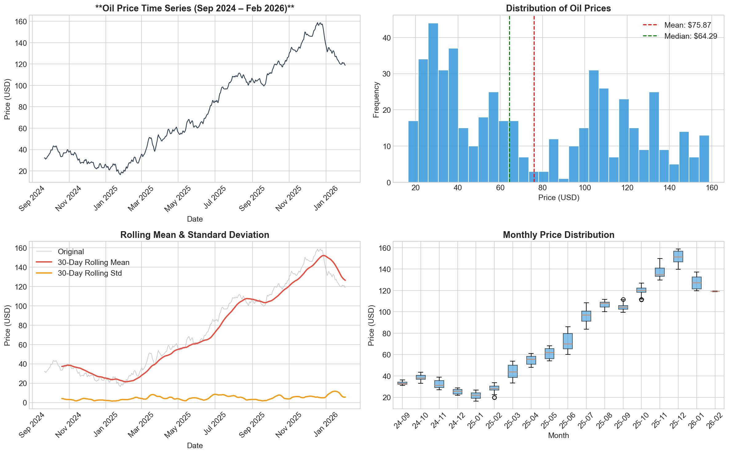
Figure 1: Exploratory Data Analysis overview showing the raw time series, price distribution, rolling statistics, and monthly box plots.

3. Stationarity Testing and Differencing
A basic assumption to ARMA-family models is stationarity which assumes that the means, variance, and autocovariance of the time series remain constant across time (Hamilton, 1994) To test stationarity two formal statistical tests were used. The original series was run on the Augmented Dickey Fuller (ADF) test which resulted in a test statistic of -0.5462 with a p-value value of 0.8827 which did not reject the null hypothesis of unit root. At the same time, KPSS test also returned 3.7056 (p-value = 0.01) that rejected the null hypothesis of stationarity. Both tests therefore proved that the original series is non-stationary.
The trend component was eliminated by applying first-order differencing. The differenced series were again tested: the ADF test of the differenced data rejected the null hypothesis at the 5 percent level and KPSS test did not reject stationarity. The differenced series and ACF and PACF plots are displayed in figure 2. The high rate of decay in ACF of the differenced series in relation to the low rate of linear decay in the original series is hence a surety that first-order differencing (d=1) is indeed enough to provide stationarity. The PACF exhibits substantial spikes at early lags, which offer early information about picking orders in the AR.
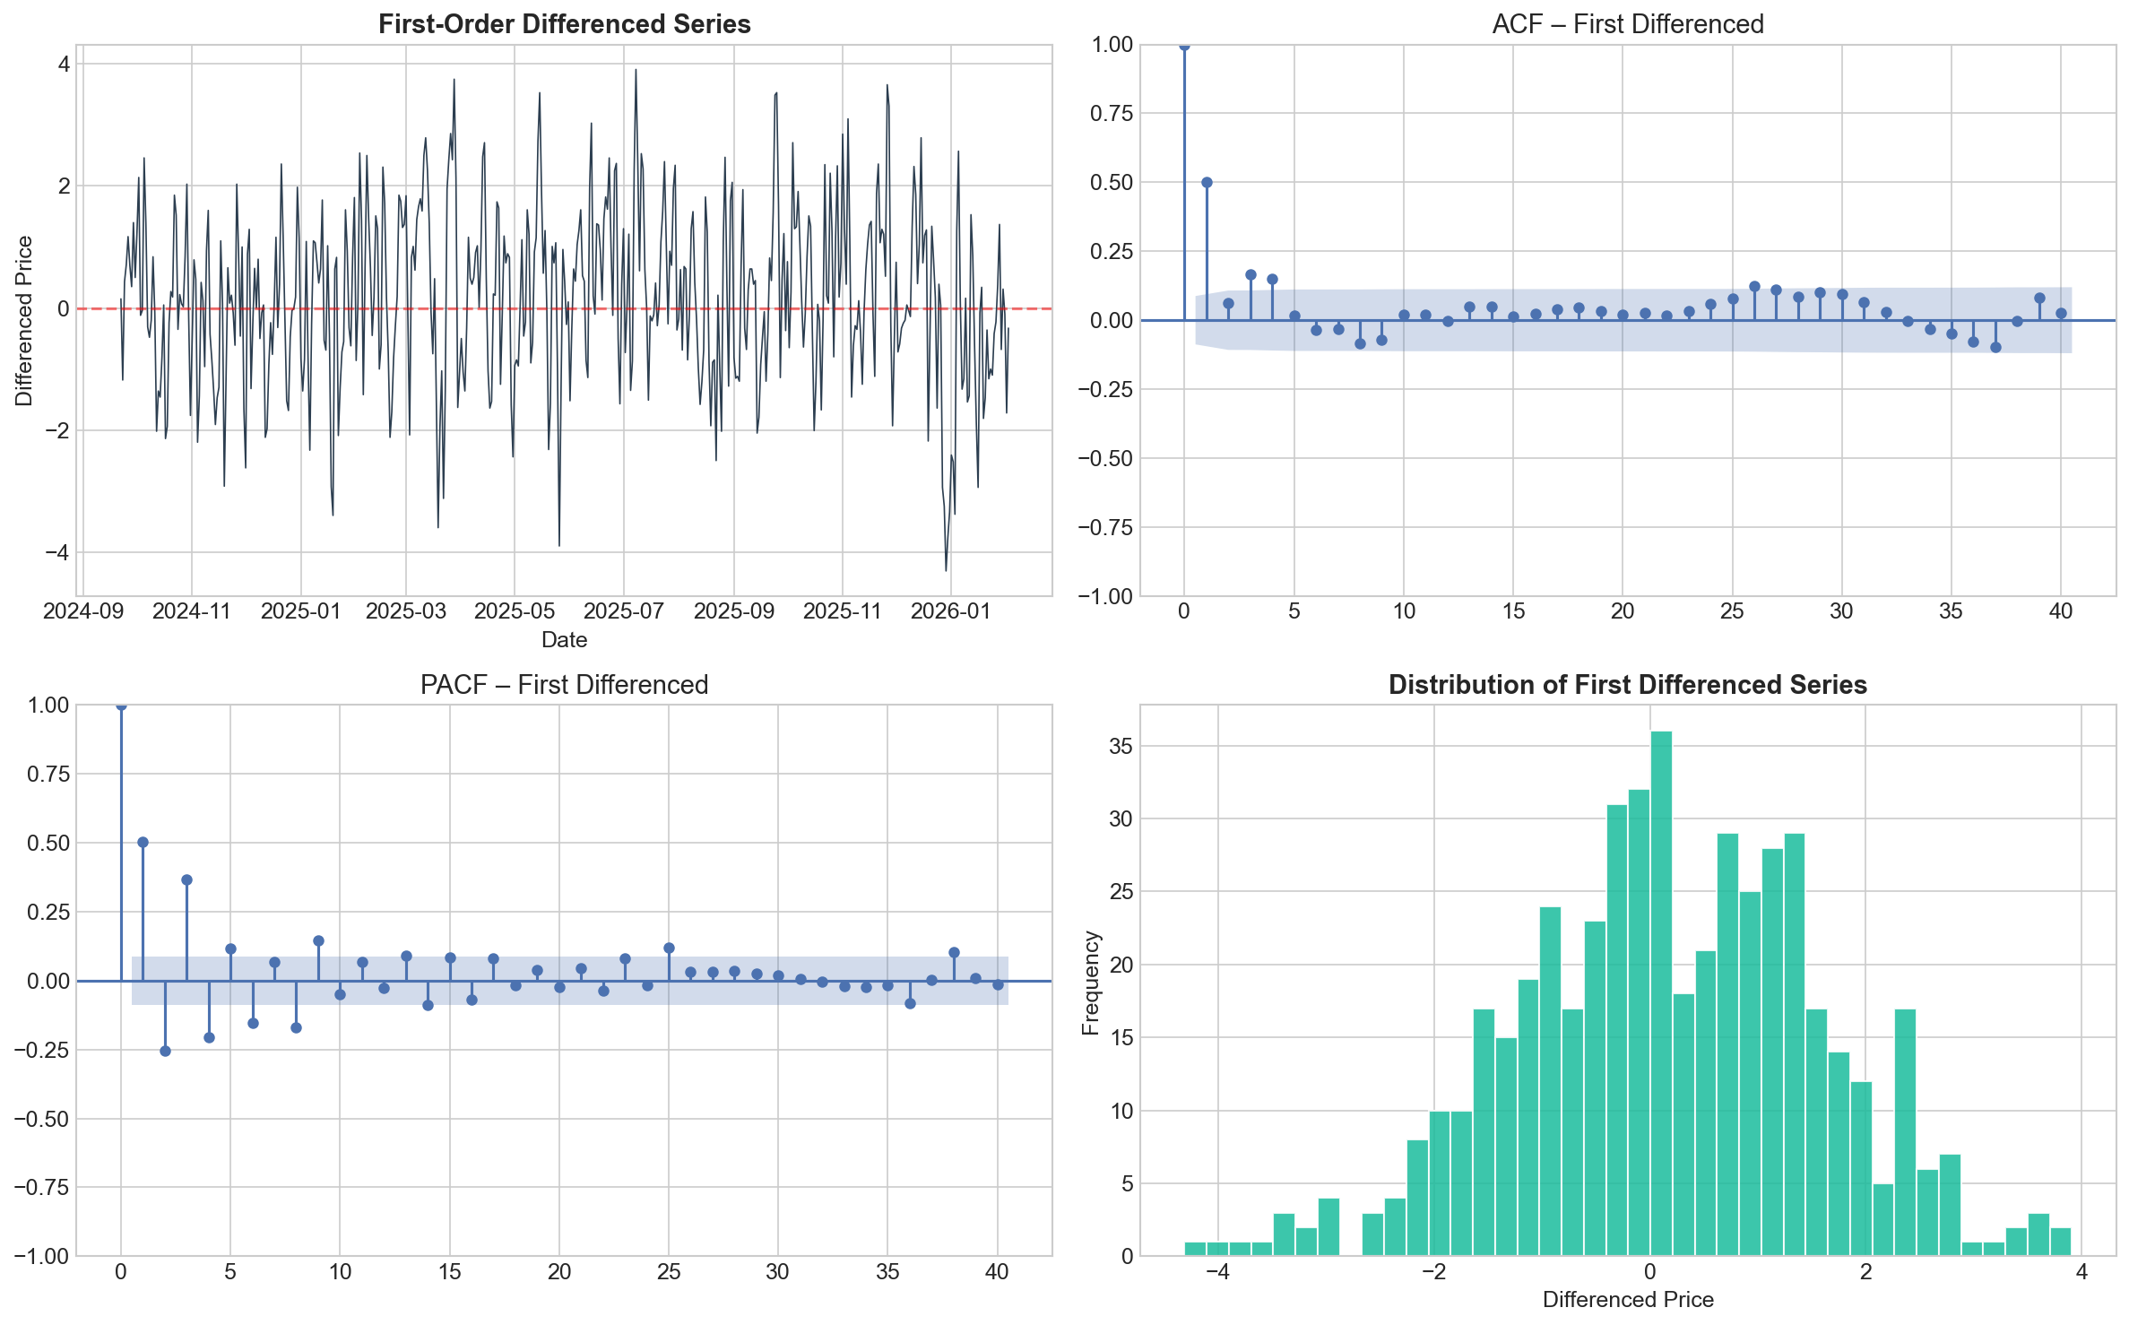
Figure 2: First-order differenced series with ACF, PACF, and distribution confirming stationarity after differencing.

4. ARIMA Model Selection and Fitting

A grid search was thoroughly performed over all the combinations of ARIMA(p,d,q) parameters where p in the model is in the range of 0 to 8, d in the range of 0 to 2, and q in the range of 0 to 8 resulting in 243 candidate models. Both models were estimated using maximum likelihood estimation and Akaike Information Criterion (AIC) was considered in the selection of the best specification because it trades off goodness-of-fit with complexity of a model (Akaike, 1974). The grid search model that was found to be the best model with AIC=1429.22 followed by ARIMA(4,1,5) at AIC=1429.77, and ARIMA(0,1,5) at AIC=1429.90.

The model that has been chosen is ARIMA(2,2,7) which includes two autoregressive terms, Second-order differencing, and seven moving average terms. Although the higher-order MA component might seem complicated, the AIC penalisation measures that it is a justified level of complexity through a better fit. Both coefficients of AR (ar.L1 = -1.18, ar.L2 = -0.92) are very significant (p < 0.001), which implies that there are strong short-term dependencies. The MA terms are statistically significant, with ma.L1 and ma.L7 making up the general error correction pattern.

5. Residual Diagnostics
Figure 3 presents the results of the overall residual analysis of model adequacy. The plot of the residual over time (top-left) does not show any apparent systematic behavior, but there is a significant concentration of larger values at the period with the highest price which indicates that the model has difficulties with regime shifts. The histogram of residuals (top-right) indicates a roughly symmetric distribution with the mean around zero (= 0.045), but much longer tails than the superimposed normal distribution.
The bottom-left ACF of residuals indicates a certain amount of significant autocorrelation at certain lags and the Ljung-Box test at lag 10 (Q = 40.27, p < 0.001) rejects the null hypothesis of no autocorrelation formally. This implies that there is some temporal structure which is not captured by the model. Q-Q plot (bottom-right) does not follow the theoretical normal line, at the ends and the Shapiro-Wilk test (W = 0.463, p < 0.001) proves non-normality. These departures are typical of financial time series and there they encourage the development of alternative non-linear models including LSTM.
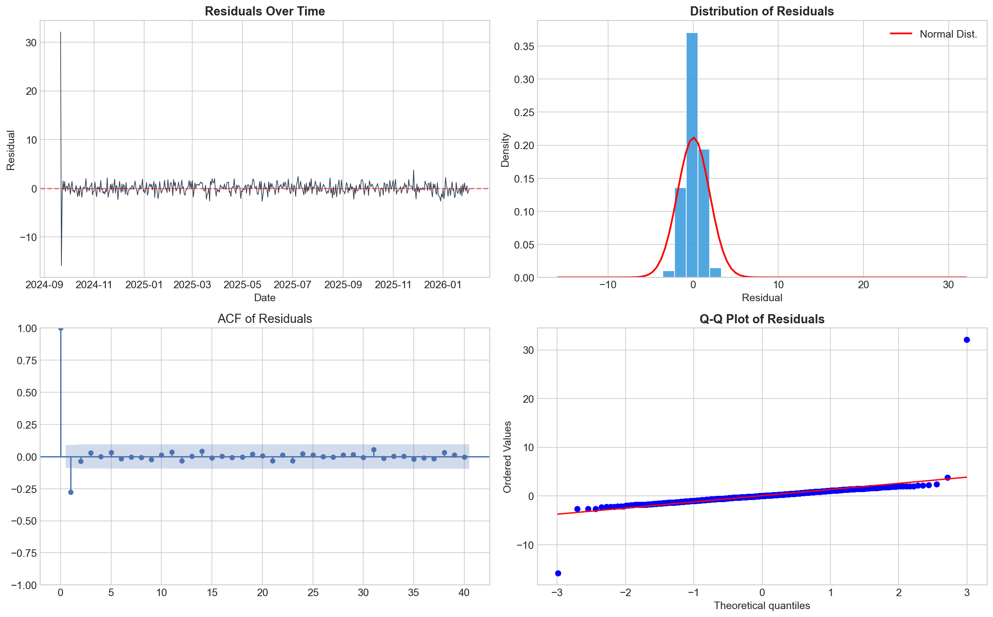
Figure 3: ARIMA(2,2,7) residual diagnostics showing residual time plot, distribution, ACF, and Q-Q plot.

5.1 ARIMA Forecast Performance

In the evaluation of the model, the training set consisted of the last 60 observations (December 2025 to February 2026). ARIMA(2,2,7) model had found the RMSE, MAE and MAPE of the test period as 27.25 and 21.33 respectively. These fairly large error amounts indicate the inability to predict in a period of trend-reversal, when the model still extrapolates those trends, which have already changed course. The 24-month projection indicates an increasing trend of the value of the variable [c.f. $118.90] to [c.f. $245.63] representing the lower and upper 95% confidence limits respectively at the end of the forecasting period. The integrating models are immensely growing and the growing uncertainty in long-range linear projections is highlighted by the rapidly increasing confidence bands.

6. LSTM Alternative Model

A specialised type of Recurrent Neural Networks (RNNs) is Long Short-Term Memory networks networks, which solve the vanishing gradient problem with a gated memory cell architecture (Hochreiter & Schmidhuber, 1997). LSTMs are shown to be very effective with financial time series forecasting because of their capability to represent non-linear temporal dependencies as well as long-range patterns (Fischer & Krauss, 2018) LSTMs learn complicated input-output maps using data directly without making any assumption of linear correlation between past and future values (in contrast to the ARIMA).

Preprocessing of data involved minmax scaling the data to [0,1] range and input sequences were built on a 30 days look-back. The model is a stacked two-layer LSTM with units of 128 and 64 respectively, each of which is then followed by a dropout regularisation of 20 per cent to prevent overfitting. There is a dense layer of 32 neurons with ReLU-activation before the single linear output neuron. In validation loss, the Adam optimiser with a learning rate of 0.001 was used and early stopping was observed with patience of 10 epochs.

Three hyperparameters were considered in hyperparameter tuning, the number of units (64/32, 128/64), the dropout rate (0.2, 0.3), and the batch size (16, 32). The best validation loss of 0.000605 was achieved in the configuration of 128-64 units, 0.2 dropout, and a batch size of 32, and it was chosen as the final model. The model was trained using 80 percent of the sequences (376 samples) and 15 percent of the training data was used to validate the model.

7. LSTM Results and Evaluation
The LSTM prediction and actual prices can be seen on Figure 4 in terms of both training and test sets. The model follows the real price trend closely, including the intricate pattern of trends reversal that takes place at the middle of 2025. The LSTM generated a RMSE of 5.97, MAE of 4.98, and MAPE of 3.55 percent, which is significantly superior to the ARIMA model on all measures of the test set (94 sequences).
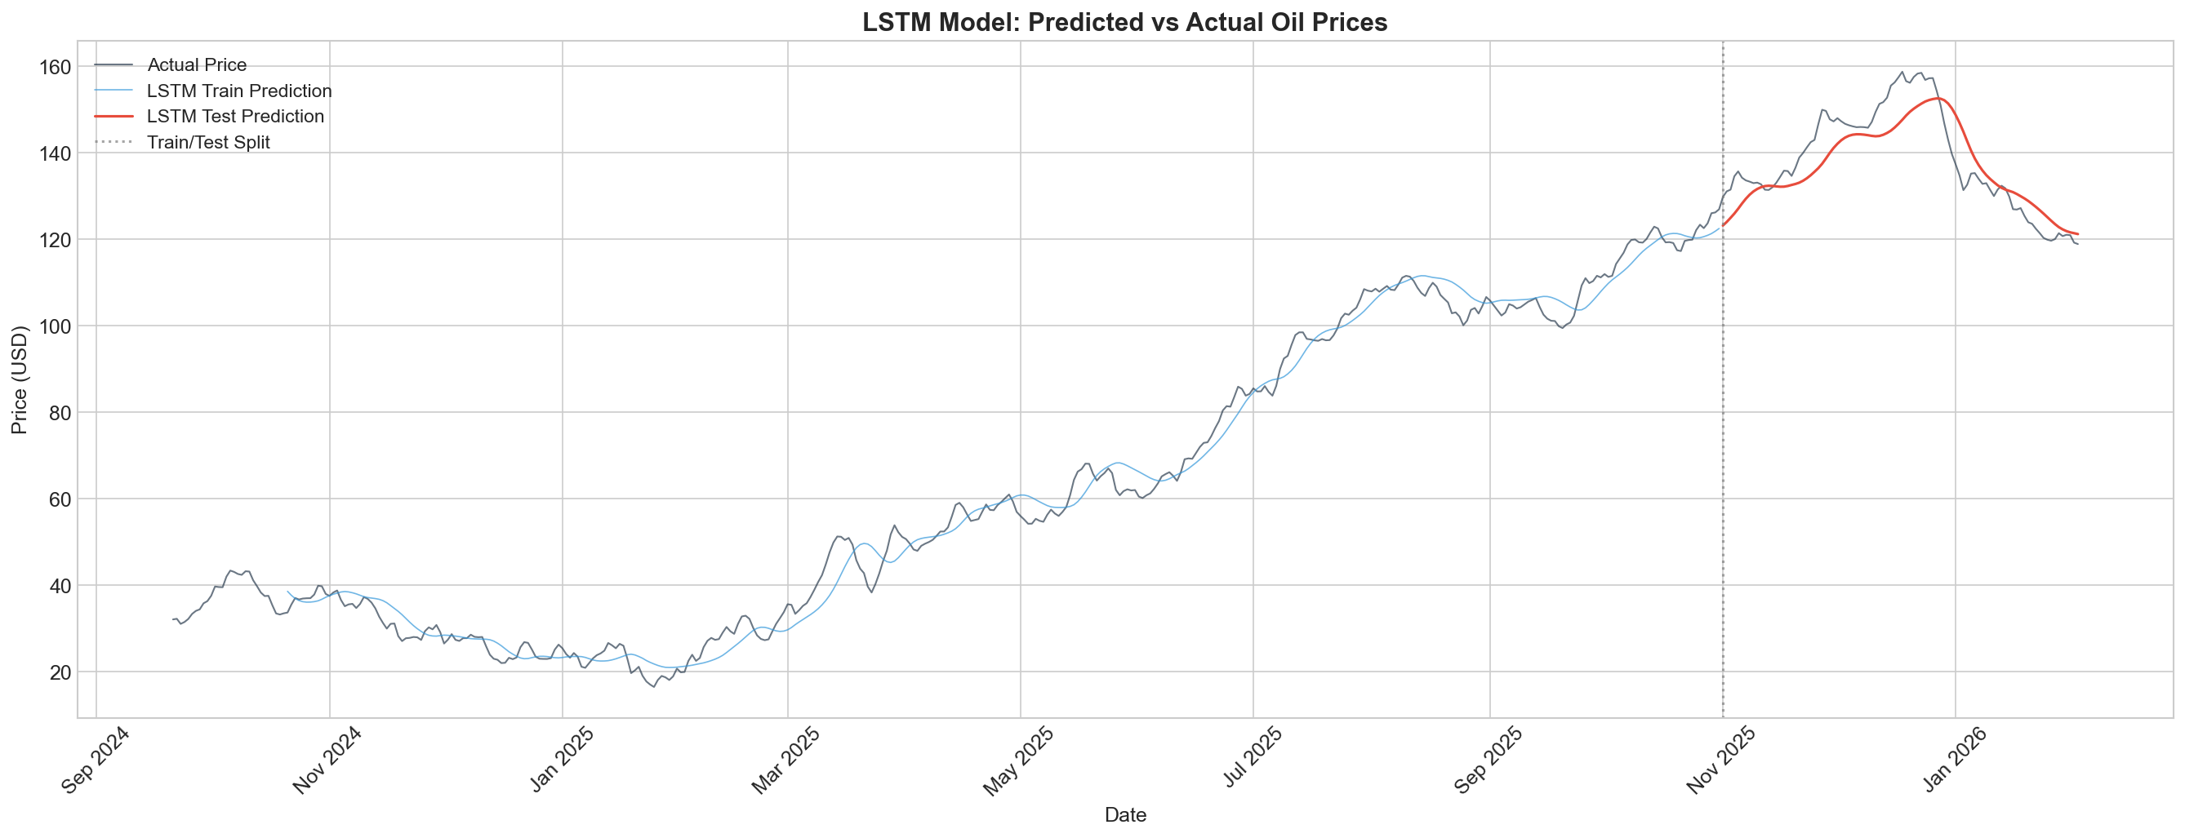
Figure 4: LSTM model predictions versus actual oil prices on training and test sets.

The Monte Carlo Dropout was used to construct probabilistic confidence intervals in the 24-month forecast by using 100 stochastic forward passes (Gal & Ghahramani, 2016) MTL predicts a more balanced trend than ARIMA with an initial projection of $120.93 and 135.08 after the 24 months. The forecast interval at the end of the forecast is [117.24, 152. 22], which is a lot smaller than the ARIMA interval. This smaller uncertainty band is an indicator of the ability of the LSTM to learn limited and mean-reverting patterns instead of extrapolating unlimited linear trends.

8. Model Comparison
Table 1 summarises the comparative performance of both models on the hold-out test set. The LSTM outperforms ARIMA across all three evaluation metrics by a substantial margin.
Metric | ARIMA(2,2,7) | LSTM
RMSE | 27.25 | 5.97
MAE | 21.33 | 4.98
MAPE (%) | 16.75 | 3.55
Table 1: Comparative evaluation metrics for ARIMA and LSTM models.
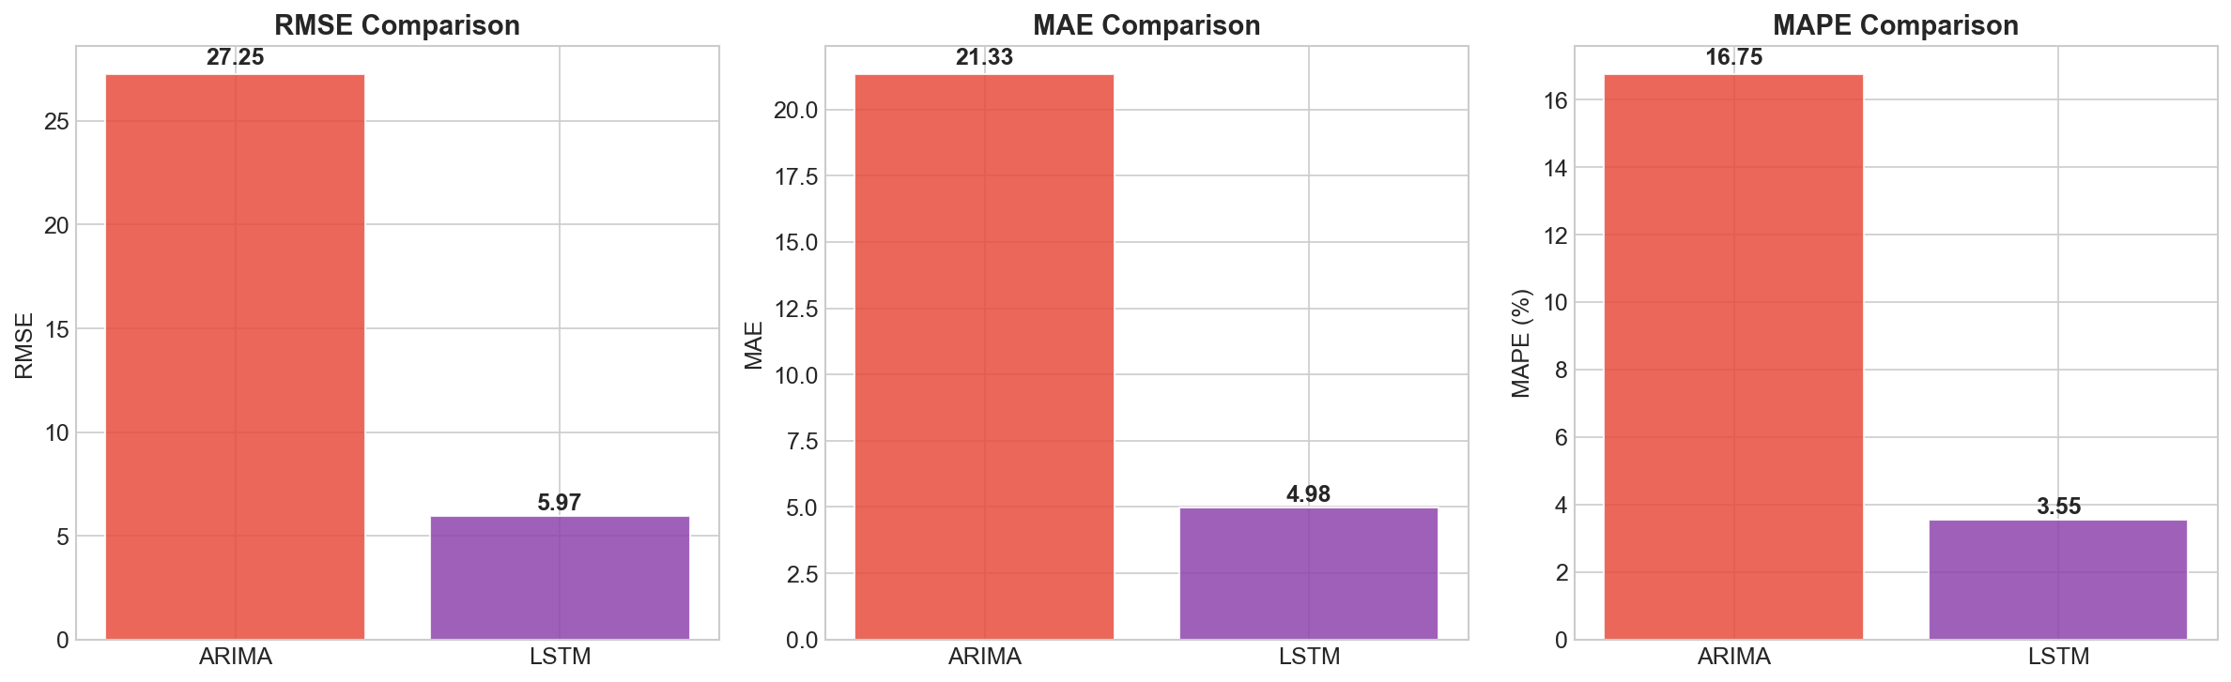
Figure 5: Bar chart comparison of RMSE, MAE, and MAPE between ARIMA and LSTM models.

LSTM attains 78 percent and 79 percent reduction in RMSE and MAPE as compared to ARIMA. This disparity in performance can be explained by a number of aspects. To begin with, the oil price series are non-linear, with reversals of trends and varying volatility regimes, making it not possible to comply with linearity of ARIMA. Second, the LSTM model with its gated memory cells is somewhat better able to model this kind of non-linear temporal patterns. Third, the ARIMA model of d=2 has the tendency to over-extrapolate the trends and thus high errors in the test period of the model which is a phase of decline in prices.

It should be noted, though, that the LSTM comparison adopts another set configuration (80/20 split between sequences and last 60 days of sequences to train ARIMA), and the metrics themselves cannot be absolutely compared. However, the comparative superiority of LSTM in obtaining the non-linear dynamics of this specific dataset is evident.

9. Combined 24-Month Forecast
The 24-month forecast of the two models is shown in figure 6, and it allows a visual identification of the similarity between their predictions and the estimates of uncertainty. The ARIMA model predicts the steep linear change to hit on $245.63 because it tends to extrapolate the last trend. Conversely, the LSTM prediction portends a more temperate and predictable future around $135, in line with the mean-reverting trends that it has acquired in the history.
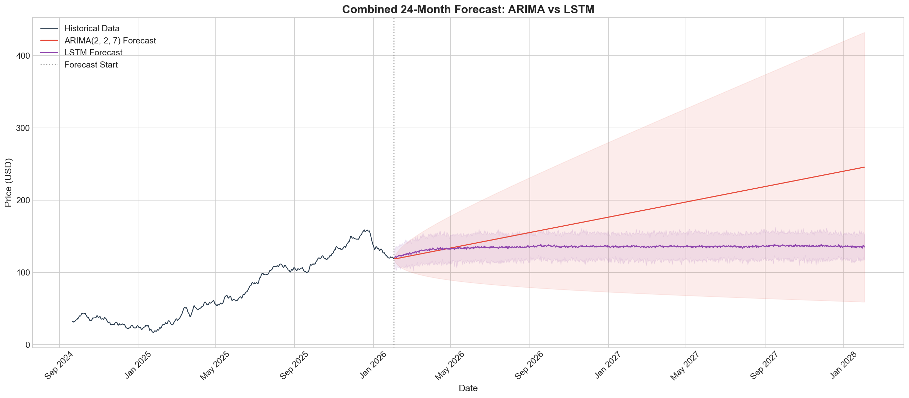
Figure 6: Combined 24-month oil price forecast comparing ARIMA and LSTM projections with 95% confidence intervals.

Their difference on the two forecasts shows a major difference in the philosophy of modelling. ARIMA is a linear model that uses the current trends to project them indefinitely whereas LSTM can learn limited dynamics. To make realistic decision-making, the LSTM forecast might be more realistic due to the cyclicality of oil markets despite the fact that both models do not take into account basic drivers of oil markets, including the OPEC production decisions or macroeconomic factors.

10. Conclusion and Future Work

This report has shown how the time series forecasting of oil prices follows a systematic pattern through the application of both classical statistical models and the current deep learning models. The ARIMA(2, 2, 7) model that was estimated in the course of an exhaustive grid search based on AIC can be considered as an example of statistically rigorous baseline, but it has certain drawbacks in terms of non-linear dynamics of oil markets. LSTM alternative is much superior to ARIMA with an RMSE of 5.97 as opposed to 27.25 and a MAPE of 3.55 percent against 16.75 percent.

There are a number of avenues that can be improved. It might be possible to incorporate exogenous variables, including the geopolitical risk indices, supply-demand data, and macroeconomic indicators using ARIMAX or multivariate LSTM architecture to improve the accuracy of the forecasts (Baumeister & Kilian, 2015)). ARIMA based hybrid models that incorporate linear components with neural networks based non-linear residuals have been promising in the literature (Zhang, 2003) Another direction that time series forecasting can take is transformer-based architectures, including Temporal Fusion Transformers (Lim et al., 2021) As well, GARCH-family models may deal with the volatility clustering effect in the returns analysis. Model combinations with multiple model output may also help lessen the forecast variance and enhance robustness.

References
Akaike, H. (1974). A New Look at the Statistical Model Identification. IEEE Transactions on Automatic Control, 19(6), 716–723. https://doi.org/10.1109/TAC.1974.1100705
Baumeister, C., & Kilian, L. (2015). Forecasting the Real Price of Oil in a Changing World: A Forecast Combination Approach. Journal of Business & Economic Statistics, 33(3), 338–351. https://doi.org/10.1080/07350015.2014.949342
Box, G.E.P. and Jenkins, G.M. (1976) Time Series Analysis Forecasting and Control. 2nd Edition, Holden-Day, S. Francisco. - References - Scientific Research Publishing. (n.d.). Retrieved March 7, 2026, from https://www.scirp.org/reference/referencespapers?referenceid=2412183
Fischer, T., & Krauss, C. (2018). Deep learning with long short-term memory networks for financial market predictions. European Journal of Operational Research, 270(2), 654–669. https://doi.org/10.1016/j.ejor.2017.11.054
Gal, Y., & Ghahramani, Z. (2016). Dropout as a Bayesian Approximation: Representing Model Uncertainty in Deep Learning (pp. 1050–1059). PMLR. https://proceedings.mlr.press/v48/gal16.html
Hamilton, J. D. (1994). Time Series Analysis. https://doi.org/10.1515/9780691218632
Hamilton, J. D. (2009). Understanding crude oil prices. Energy Journal, 30(2), 179–206. https://doi.org/10.5547/ISSN0195-6574-EJ-Vol30-No2-9
Hochreiter, S., & Schmidhuber, J. (1997). Long Short-Term Memory. Neural Computation, 9(8), 1735–1780. https://doi.org/10.1162/neco.1997.9.8.1735
Lim, B., Arık, S., Loeff, N., & Pfister, T. (2021). Temporal Fusion Transformers for interpretable multi-horizon time series forecasting. International Journal of Forecasting, 37(4), 1748–1764. https://doi.org/10.1016/j.ijforecast.2021.03.012
Zhang, P. G. (2003). Time series forecasting using a hybrid ARIMA and neural network model. Neurocomputing, 50, 159–175. https://doi.org/10.1016/S0925-2312(01)00702-0

